# NATIONAL ASSOCIATION OF UNIVERSITY WOMEN

Volume 4, Issue 7

April 2014

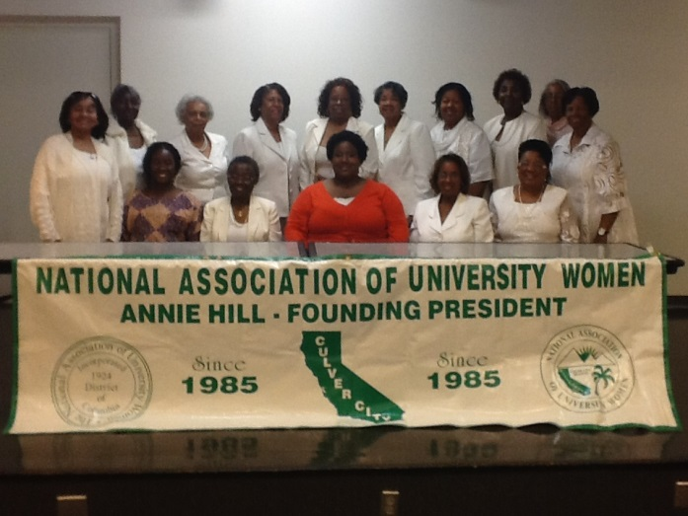

**My NAUW Culver City Sisters,**

It was so good to hear from our previous Scholarship Recipients at our last meeting in March. **Sharmel Jackson and Shirldawn Williams** were our special guests and shared their college experiences with us and expressed their gratitude to the **Culver City Branch** for their scholarships. They were both lovely and accomplished young women. It would be great if we could recruit them to join the **Culver City Branch** to bring new ideas and new members to our branch.

This month, we will have our **Community Fair** in conjunction with **St. John’s United Methodist Church (located at 1715 Santa Ana Boulevard)**, on **Saturday, April 26th from 10:00 a.m. to 1:00 p.m.** Please note the time change. All members need to support our health project event. If you have any supplies to contribute or grocery cards to donate to the cause, they will be greatly appreciated. These items can be brought to our meeting on **Sunday, April 13th**. If donations are made after this date, separate arrangement can be made to collect them.

We were unable to register 25 women thus far, so the **mobile mammogram will not be available on April 26th.** However, whenever we do reach the magic number, then I can call the health clinic and they will come out to conduct the exams. They will not come out for less than 25 women because their workers are paid overtime for this service. We can sign up women on the day of the **Community Fai**r instead. The **Community Fair** will go on without them. We will have other health screenings available. With everyone’s help, we can still have a very successful event.

At Sunday’s meeting, we will begin the nomination process for new officers. The election will be held in May and the induction ceremony for new officers will take place in June.

Don’t forget to send in your registration for the **National Convention in New Orleans from July 29-August 3, 2014, at the J.W. Marriott Hotel.** The early bird registration expired on March 30th. The next deadline is May 15th for regular registration in the amount of $350. If you have not received your registration packet yet, please let me know as soon as possible. We hope to have a good representation from the **Culver City Branch**. It is a great opportunity to learn more about **NAUW** and see that we are a nationwide organization with a new branch in Liberia.

**Helen Ricks, President**

.

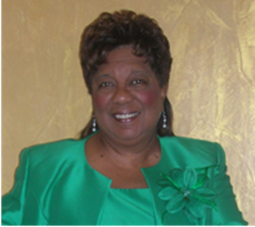

CULVER CITY STAR

## **PRESIDENT’S CORNER**

culver city nauw:

**Executive Board 2012-2014**

**President**

**Helen Ricks**

**1st Vice President**

**Mildred Slaughter**

**2nd Vice President**

**Carolyn Williams**

**Recording Secretary**

**Clarissa Andrews**

**Corresponding Secretary**

**Herracia Brewer**

**Financial Secretary**

**Hester Watkins**

**Treasurer**

**Kenya Dennis**

**Historian**

**Dr. Virginia Hathaway**

**Parliamentarian**

**Dr. Claretha Graham**

**Immediate Past President**

**Mildred Slaughter**

**SECTIONAL DIRECTOR**

**EVELYN L. WRIGHT**

**NATIONAL PRESIDENT**

**DOLORES Y. OWENS**

**NATIONAL THEME:**

**“Women Moving Forward with Purpose and Pride”**

**CULVER CITY STAR**

Page 2

BIRTHDAYS AND ANNIVERSARIES

**April**

**Lillie Tobin Jackson 4/6**



Be of good courage, and he shall strengthen your heart, all ye that hope in the Lord.

Psalms 31:24



SICK AND SHUT-IN

### **Dates to Remember**

**Community Fair Saturday, April 26, 2014 St. John’s UM Church 1715 Santa Ana Blvd.**

**Spotlight on Youth Luncheon, Sunday, April 27, 2014, 1:00 p. m. Doubletree by Hilton Torrance $65**

**Jazz Brunch/Scholarship Inland Empire Branch May 3, 2014 Sheraton Hotel (Featuring Barbara Morrison) 11:30a-3:00p Tickets $65**

**National Convention- July 29- August 3, 2014 – New Orleans J.W. Marriott Registration-$350**

**Mailing Address**: NAUW Culver City Branch P.O. Box 2524 Culver City CA 90231-2524



Continue to pray for the following members: Odessia Love, who is recuperating; Carolyn Williams, her sister was in the hospital. Keep Dr. Virginia Hathaway and her family in prayer. Her mother was recently hospitalized.

